QUARTERLY REPORT FOR

THE CALIFORNIA INSTITUTE OF TECHNOLOGY

TRANSIENT ABSORBANCE AND OPTICAL POWER LIMITING OF OSMIUM PHTHALOCYANINES

Joseph W. Perry, Matthew M. Sartin, Matteo Cozzuol
School of Chemistry & Biochemistry
Georgia Institute of Technology
901 Atlantic Dr. NW
Atlanta, GA 30332-0400

Phone: 404-385-6046
Fax: 404-385-6057
E-mail: joe.perry@chemistry.gatech.edu

June 19, 2008

OBJECTIVE:
Understand how to improve the performance of opto-electronic materials by using molecules with well-defined structures.

APPROACH:
Investigate multichromophoric systems for photoinduced charge generation or energy transfer and optical absorption. Perform spectroscopic characterization of charge generation, transient optical properties, and optical limiting properties.

MILESTONES:
To develop materials for efficient charge carrier generation or energy transfer and long lifetimes. To develop high sensitivity, broadband, high dynamic range nonlinear absorptive materials for optical limiting.

ACCOMPLISHMENTS

Performed optical power limiting and transient absorption spectroscopy on two osmium naphthalocyanines that showed optical power limiting at 532 nm in solution. Each has a strong, additional, transient band at 425 and 450 nm, respectively.

RESULTS

We have performed transient and nonlinear optical studies on a pyridine-substituted and a triphenylphosphine-substituted osmium naphthalocyanine (OsNcPy and OsNcPPh₃), whose structures are shown in Fig. 1. These were synthesized by the Marder group. The linear electronic absorption spectra in toluene are shown in Figure 2. The spectrum of OsNcPy shows a Q-band absorption at 695 nm and a minimum at 550 nm. The OsNcPPh₃ also shows a Q-band absorption at 699 nm and a minimum at 550 nm; however, the absence of the charge transfer band seen in the OsNcPy makes the transmittance window larger for OsNcPPh₃.

Optical power limiting data were taken on OsNcPy and OsNcPPh₃ in toluene using an f/5 optical geometry, 532 nm, 5 ns laser pulses, and a 10 Hz repetition rate, as shown in Fig. 3. Significant optical limiting was observed at both wavelengths. The

initial transmission at 532 nm was 70%, and the observed suppression (T_{linear}/T_{Emax}) was 1.04 at 100 μJ. Temporary equipment problems have prevented the use of higher energies (usually up to 2 mJ), where we expect to see greater suppression, and suppression was unobservable in OsNcPy under these conditions. Figure 3b shows the optical limiting behavior of a sample with 30% transmittance at the excitation wavelength, in which the suppression is more apparent. The response for OsNcPPh₃ was compared with that of an InClPc(t-butyl)₄ solution in toluene with a 70% transmission at 532 nm where the limiting data were taken; InClPc(t-butyl)₄ is known to be a high performance optical limiting dye at this wavelength. The suppression of the InClPc(t-butyl)₄ solution was observed to be 15 at 532 nm in the same geometry.

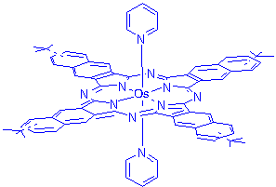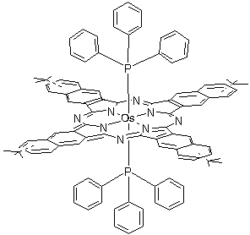

(a) (b)
Figure 1. Structure of (a) OsNcPy and (b) OsNcPPh₃.
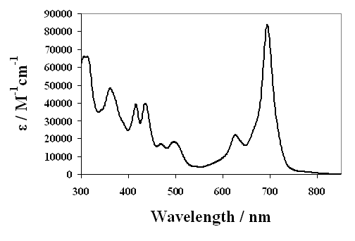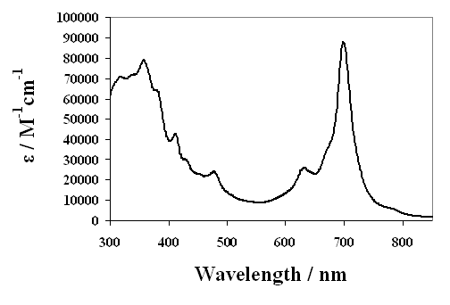
(a) (b)
Figure 2. Visible absorption spectra of (a) OsNcPy and (b) OsNcPPh₃.

In order to obtain some insight into the mechanism of the optical limiting, we performed nanosecond transient absorption spectra on OsNcPy and OsNcPPh₃ in toluene. The transient difference spectra are shown in Fig. 4. Transient bleaching of the Q-band and the shorter wavelength absorption band is observed. Both molecules exhibit a weak induced absorption at ~ 560 nm, which is attributed to absorption from the triplet state. If unit intersystem crossing efficiency is assumed, the extinction coefficients of these transients at 532 nm are 5×10³ M⁻¹cm⁻¹ for OsNcPy and 1.0×10⁴ M⁻¹cm⁻¹ for OsNcPPh₃. They exhibited a stronger absorbance at short wavelength. Again, if 100% intersystem crossing is assumed, ε = 7.4×10⁴ M⁻¹cm⁻¹ at 455 nm for OsNcPy, and 2.3×10⁵ M⁻¹cm⁻¹ at 425 nm for OsNcPPh₃. This shorter wavelength absorbance probably indicates a transition to a higher excited triplet state.

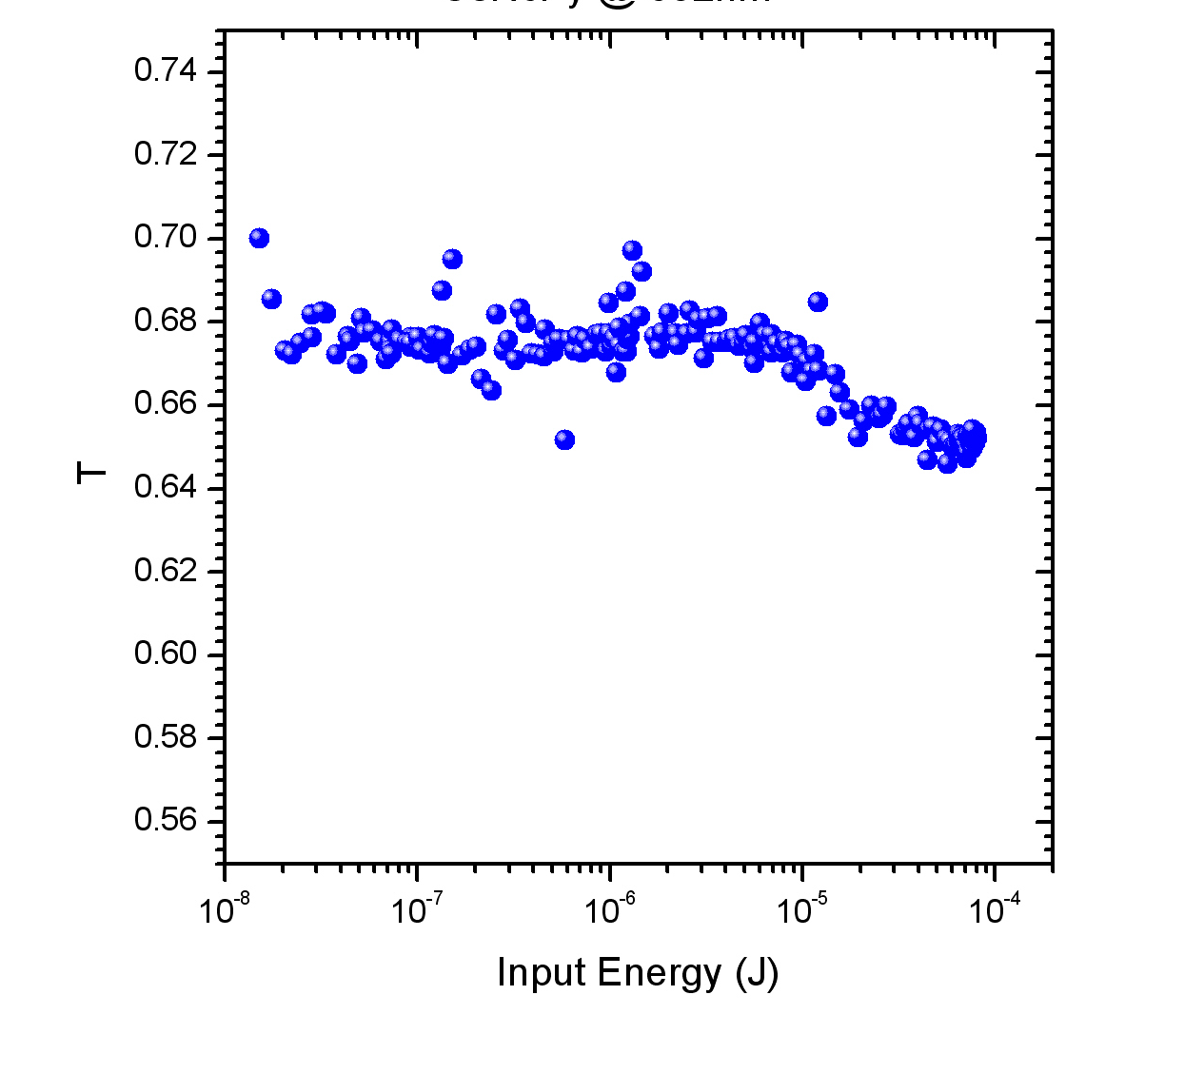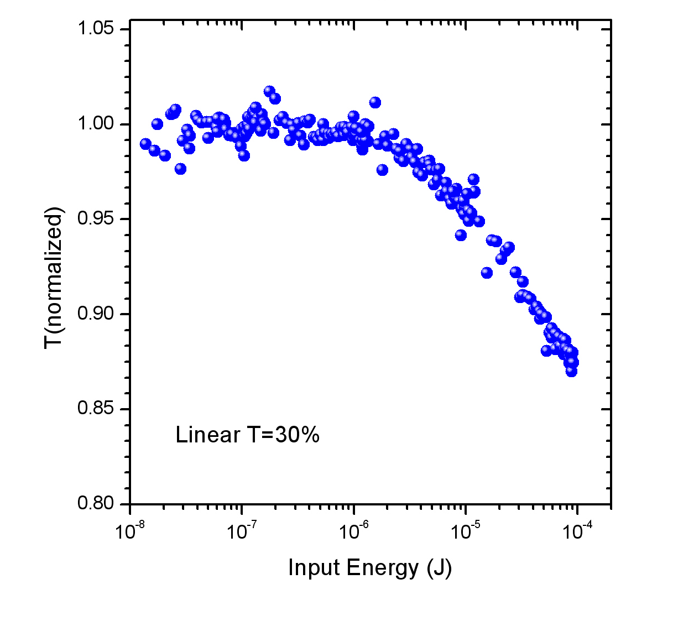
(a) (b)
Figure 3. Optical power limiting data for OsNcPPh₃ in toluene excited at 532 nm. (a) 70% transmittance (b) 30% transmittance

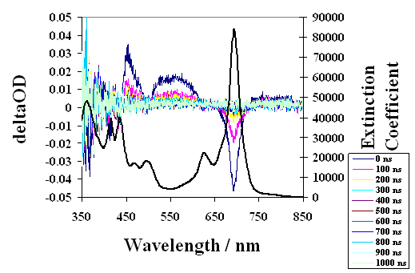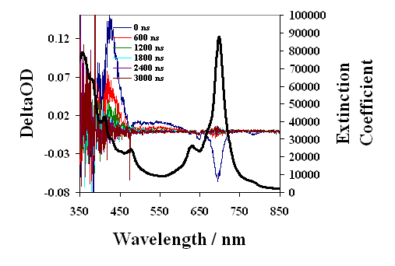
(a) (b)
Figure 4. Transient absorption spectrum (a) OsNcPy and (b) OsNcPPh₃ in toluene excited at 680 nm (OD = 0.2).

CONCLUSIONS

We have shown that two osmium naphthalocyanines show optical limiting at ~532 nm for nanosecond laser pulses consistent with a reverse saturable absorption mechanism. In addition to the photoinduced absorbance at 560 nm, both molecules exhibit a stronger, short wavelength transient absorbance (455 nm for OsNcPy and 425 nm for OsNcPPh₃) that probably results from an accessible higher triplet state.

In future work, we will attempt to further characterize the spectroscopy of the molecules. Additionally, we can repeat the optical limiting experiments when the technical difficulties with our current system are resolved, to obtain a clearer representation of the optical suppression capabilities of these materials. More materials of this sort will be analyzed in the future.

